When Does SARB Balance Sheet Expansion Affect Banking Sector Stability? Evidence from a State-Dependent Approach

Lindokuhle T Zungu
Executive Summary
This paper adopted two complementary models, namely state-dependent Bayesian Structural Vector Autoregression as the main model and the state-dependent Bayesian Instrumental Variable Local Projection framework as the robustness model. These models are adopted to investigate the state-dependent effects of macrofinancial shocks on banking sector stability, focusing on the role of central bank balance sheet expansion and broader macroeconomic transmission channels in South Africa. The analysis contained vigorous evidence of a nonlinear dynamic linking macroeconomic shocks to bank capital resilience. The credit-to-GDP gap as the state variable defined in this paper is consistent with those of international practice with macroprudential policy design and financial stability surveillance.
The impulse response designates that the transmission of shocks to Tier 1 capital varies significantly across financial episodes, showing that it is highly nonlinear. In the elevated episode of financial stress, the response is more pronounced and persistent, subject to greater uncertainty, reflecting the amplification mechanisms associated with balance sheet constraints, elevated risk premia, and tighter financial conditions. While the banking sector demonstrates resilience in the low financial stress, the response to shocks is generally moderate in magnitude, stable over time, and supported by relatively tight credible intervals. The key finding for this paper is that during the low-stress environment, central bank balance sheet expansion has a positive and stabilizing effect on bank capital, operating primarily through liquidity provision and asset price support channels. Although, in the high-stress conditions, this effect becomes weaker and less predictable, pointing out that the effectiveness of such central bank interventions is contingent on the functioning of financial intermediation. This result highlights the importance of calibration and timing in the implementation of unconventional monetary policy tools. The analysis further shows the policy rate used to capture conventional monetary policy in the elevated policy has a more limited impact on banking sector stability, while in normal times interest rate adjustments exert a modest influence, and their transmission weakens when financial frictions intensify. This finding underscores the limitations of relying solely on the interest rate channel in the presence of systemic financial stress and supports the use of complementary policy instruments. Exchange rate, inflation, and real residential property price (which proxies collateral values) shocks exhibit strong regime-dependent effects, with adverse impacts on bank capital being significantly amplified during high-stress periods. The collateral values play a crucial role in shaping bank balance sheet dynamics, especially when credit conditions are tight. These findings are in line with the broader literature on the role of asset prices in amplifying macro-financial linkages and financial cycles.
From a policy point of view, the results underscore the significance of incorporating financial cycle considerations into the formulation of monetary and macroprudential policies. The credit-to-GDP gap appears as a significant indicator for detecting periods of systemic risk buildup and further for guiding countercyclical policy interventions. Therefore, this means the active use of macroprudential tools, including borrower-based and capital buffer measures, is crucial to enhance the resilience of the banking sector and to mitigate the buildup of vulnerabilities. Furthermore, the results point to the need for a flexible and integrated policy framework that allows for coordinated responses across monetary, macroprudential, and financial stability domains. In particular, during periods of elevated stress, policymakers may need to deploy a broader set of instruments, including liquidity support measures and targeted interventions, to stabilise the financial system and support the transmission of policy.
Overall, the finding offers robust empirical evidence that financial stability dynamics in South Africa are inherently state-dependent and shaped by the interaction between macroeconomic shocks and the financial cycle. Therefore, these results underscore the significance of embracing a forward-looking and state-contingent policy approach to safeguard banking sector resilience and further to support sustainable economic growth.

When Does SARB Balance Sheet Expansion Affect Banking Sector Stability? Evidence from a State-Dependent Bayesian SVAR

Lindokuhle T Zungu

Abstract
This paper investigated the state dependent impact of macro financial shocks on banking sector stability in South Africa, using two complementary emprirical approach, namely a Bayesian Structural Vector Autoregression and a Bayesian Instrumental Variable Local Projection framework, where both of these model feature the regime dependence based on the credit to GDP gap. The main focus of the paper is to exemine the role of central bank balance sheet expansion and broader transmission channels. The regime dependence approach allows for the identification of nonlinear dynamics across the high and low financial stress environments. The imprical finding offers a robust evidence as it shows that the response of Tierq capital is highly state contingent, as in the high stress episode the responses are amplified, more persistent, and subject to greater uncertainty, while a relatively moderated and stable effecys is witness in the low stress regime. The expansion on the central bank balance sheet is found to support the banking sector resilience, however, it effectiveness weakens under elevated stress conditions. While in the elevated period conventional monetary policy exhibite limited influence, highlighting the significance of complementary macroprudential tools. For policy implications, the finding of this study underscores the critical role of the financial cycle in shaping macro financial transmission and support the adoption of a state contingent and integrated policy framework to enhance financial stability in South Africa and other emerging market economies.

Keywords:
- Introduction
The growth of central banks' balance sheets has become a key part of modern monetary policy, especially in response to systemic crises and binding lower bound constraints. Central banks have increasingly relied on liquidity operations and large-scale asset purchases since the 2007/2009 global financial crisis to support banking systems and to stabilize financial markets. While these interventions have proven effective in restoring market functioning, their implications for banking sector stability remain complex and state-dependent. According to the BIS (2016) and BIS (2024), the balance sheet policies have a dual role as they simultaneously alter risk-taking initiatives and ease financial conditions within the banking sector. Emerging markets, particularly South Africa, are prone to these dynamics as they become very complicated due to their systems being exposed to global liquidity cycles. Therefore, shocks originating from advanced markets spread through exchange rates, capital flows, and domestic financial channels (Miranda-Agrippino & Rey, 2020; Rey, 2015). The South African Reserve Bank's evolving role as a central bank balance sheet reflects the necessity to balance monetary accommodation with financial stability objectives in an open and financially integrated economy.
The theoretical underpinnings of this relationship are anchored in three complementary frameworks such as the lender of last resort theory (Bagehot, 1873), the ‘financial accelerator framework’ (Bernanke, Gertler, & Gilchrist, 1999), and portfolio balance theory. The lender of last resort theory established the central bank principle that they should provide liquidity during elevated periods or crises to prevent systemic collapse. This role has increasingly been adopted in the modern settings to include active balance sheet management. The portfolio balance theory advocated by Tobin (1969) extended the argument in the context of quantitative easing, arguing that central bank asset purchases decrease the supply of safe assets, compress yields, and induce portfolio rebalancing toward riskier assets, thereby supporting bank capital (Vayanos & Vila, 2021; Gagnon et al., 2011). The financial accelerator framework advocated by Ben Bernanke, Mark Gertler, and Simon Gilchrist (1999) demonstrates how balance sheets and shocks to net worth are amplified through credit frictions, generating nonlinear macrofinancial dynamics. These frameworks jointly indicate that the effectiveness of balance sheet expansion is inherently state contingent and closely linked to the financial cycle.
Empirical evidence on these subjects strongly supports these theoretical insights. Going far back, the study by Gagnon et al. (2011) and Krishnamurthy and Vissing Jorgensen (2013) supported the portfolio balance theory advocated by Tobin (1969). While recent work by Miranda-Agrippino & Rey (2020) and Rey (2015) emphasizes the role of global financial cycles, arguing that expansion on the central bank balance sheet in developed markets drives global liquidity conditions and influences financial stability in emerging markets. Jordà et al. (2013) and Auerbach and Gorodnichenko (2012) argue that macroeconomic responses are highly nonlinear and depend on the state of the economy. BIS (2016) reinforces these findings, arguing that balance sheet policies act as a key stabilization tool during crises by providing liquidity and reducing funding uncertainty. On the other side, recent IMF and BIS contributions highlight that prolonged balance sheet expansion may affect bank profitability and risk-taking behavior, with implications for long-term financial stability (Borio et al., 2017). Contrasting the growing body of knowledge on this subject matter, limited attention has been given to the joint role of domestic financial conditions and external liquidity shocks in shaping banking sector stability in emerging markets.
Furthermore, the long-term implications of expansion on the central bank balance sheet remain the cornerstone debate in the financial stability literature despite these stabilizing effects. Some studies presume that prolonged liquidity provision may encourage excessive risk-taking within the banking sector. When financial institutions are in an environment of low interest rates and abundant liquidity, they may expand leverage, increasing credit aggressively, and invest in riskier assets. Hence, that may threaten banking sector stability in the future as it can contribute to the buildup of financial vulnerabilities (Borio & Zhu, 2012; Adrian & Shin, 2010). These concerns are particularly relevant in emerging market economies such as South Africa, where financial systems are often influenced by external shocks and volatile capital flows. While the South African central bank has maintained a strong reputation for prudent monetary policy and financial regulation, the potential impact of balance sheet expansion on banking sector stability remains insufficiently explored. Understanding whether central bank asset expansion strengthens bank resilience or contributes to financial imbalances is therefore an important issue for policymakers and researchers.
Therefore, the study seeks to contribute to the literature by integrating insights from the financial cycle, nonlinear policy transmission, and external shock identification within a unified empirical framework, building on Jordà et al. (2013) and Auerbach and Gorodnichenko (2012) approaches and recent advances in external instrument identification. The analysis employs a state-dependent Bayesian SVAR as the primary model and a Bayesian IV state-dependent local projection framework as a robustness approach. Investigating the relationship between balance sheet expansion by the South African Reserve Bank and the stability of the South African banking sector. The study examines whether increases in central bank assets improve banking sector resilience through enhanced liquidity and credit provision or whether they encourage risk-taking that may increase financial fragility. Focusing on macrofinancial effects of central bank balance sheet expansion, the study provides new insights into the role of monetary policy in maintaining financial stability in emerging market economies. The dual methodology adopted in this paper enables the capture of the endogenous macrofinancial interactions while isolating exogenous global liquidity shocks through the Federal Reserve balance sheet.
The results provide strong evidence of state-dependent and nonlinear effects of monetary policy on banking sector stability, where balance sheet expansion and asset price channels have significantly larger and more persistent effects on Tier 1 capital during periods of elevated financial stress. While conventional policy tools exhibit weaker transmission. The consistency of findings across both models confirms the robustness of the results and underscores the importance of financial cycle conditions and global liquidity spillovers in shaping banking sector resilience in South Africa and other emerging market economies.
- Economic Background and Stylized Facts
This section offers a comprehensive visual view of the evolution of the key financial variables covering the period 1984-2025 to build the foundation for investigating how the SARB balance sheet expansion impacts the banking sector stability. Figure 1 contains 5 panels from panel A to F capturing the central bank balance sheet (log of SARB assets), banking sector capitalization (Tier 1 capital ratio), balance sheet vs. bank stability (standardized SARB assets and Tier 1 capital), and credit-to-GDP, while the ratio captures the evolution of the financial cycle and credit-to-GDP gap, quantifying the deviations from the long-term trend in credit-to-GDP using an HP filter, respectively. Panel A illustrates the trajectory of the SARB’s total assets over time.
Following the existing literature, the central bank balance sheet was transformed into a logarithm to make the variable in the growth pattern visible to the shock. Visually, it highlights that during the 2008-2009 global financial crises and the COVID-19 pandemic, there were rapid balance sheet expansions. These upward trends capture the unconventional monetary policy actions by SARB during financial stress to support the banking system. While Panel B offers the development of the bank capitalization over time. For the bank capitalization, the tier 1 risk-based capital is adopted since it signifies the core equity that banks hold to absorb losses; meanwhile, high values indicate stronger resilience. Zooming both panel A and B in conjunction it provides interesting intuition regarding the potential impact of balance sheet expansions on bank stability. It is observed that in most instances where there are spikes in SARB assets, they coincide with stable Tier 1 ratios, signaling that liquidity support may help maintain bank capitalization. However, the relationship between SARB and Tier 1 ratios may not be uniform across the time periods, signifying the importance of the state-dependent structural VAR to capture the potential nonlinearities.

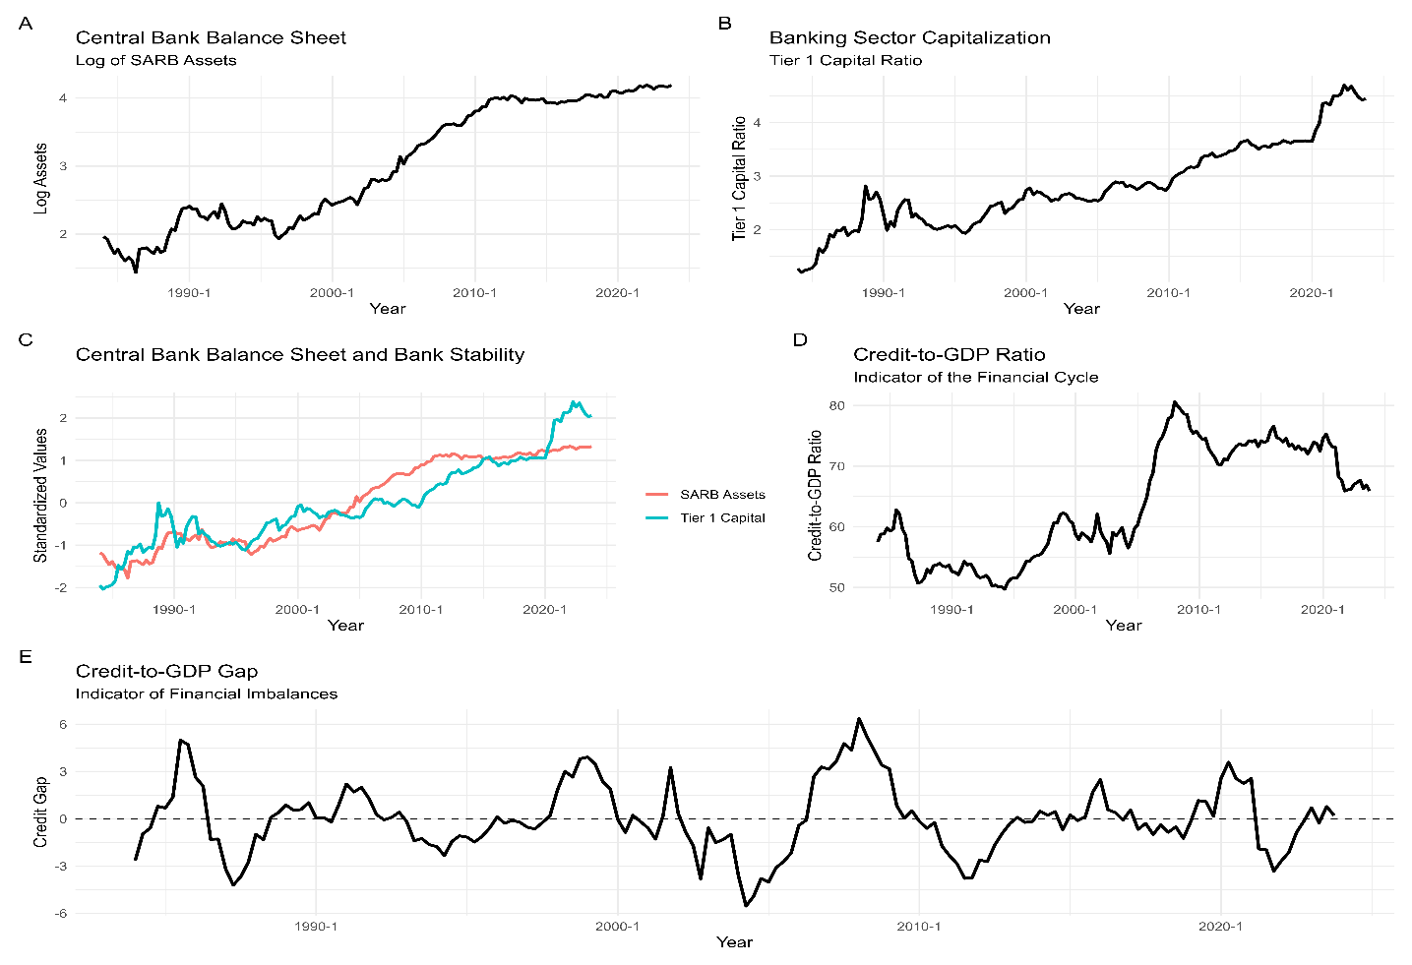
Figure 1. Stylized Facts: Central Bank Balance Sheet Expansion, Banking Sector Stability, and Financial Cycles in South Africa
Source: Author’s calculation using Rstudio softwear based on ()data.
While Panel C and D contain trends of the standardized Tier 1 capital and SARB assets, comparing these two variables directly in a standardized scale and the credit-to-GDP ratio show the evolution of the financial cycle. The visualization in panel C helps to assess a clearer co-movement of the central bank interventions and bank capitalization. Intuitively, a positive co-movement indicates increases in the SARB balance sheet are correlated with improvement in bank capitalization, while divergence may signal periods when expansionary policy alone is insufficient to stabilize banks during systemic financial stress. Conversely, panel D, the credit-to-GDP ratio, signals the overall leverage in the economy, with higher values indicating rapid credit growth relative to output.
The credit-to-GDP ratio is central for the SBVAR since it assists in capturing whether the response of the banking sector to balance sheet expansion is state-dependent; for instance, despite the central bank support in the high-credit regime, banks may be more vulnerable to shocks. Lastly, panel E contained the plots of the credit-to-GDP gap, which quantifies the deviation from the long-term trend in credit-to-GDP utilizing an HP filter. The negative gaps signal the subdued credit growth, while positive gaps indicate financial system overheating and higher fragility. This offers the economic perception for the nonlinear effect, showing that during the larger positive gaps, balance sheet expansion might have limited stabilizing impact due to heightened systemic risk, while during negative gaps, liquidity injection may have a stabilizing effect. In summary, the five-panel in figure 1 visually offers a strong motivation emanating from the central hypothesis of this paper, as it primarily shows that the impact of SARB balance sheet expansion on banking sector stability is state-dependent, varying with underlying financial conditions. This further justifies the model to be adopted in this study, which is the state-dependent SBVAR, where the credit-GDP gap is utilized as the threshold variable for identifying different regimes. Logically, this demonstrates the dynamic interplay between central bank intervention, financial cycle condition, and bank capitalization, enabling the basis for the nonlinear empirical analysis.
- Literature review ( 3 pages)

  - SARB Balance Sheet Expansion and Banking Sector Stability Theory

In recent years of financial and economic stress, the central bank balance sheet expansion has become a central policy instrument for maintaining financial stability. Diving into the South African case, the South African reserve bank balance sheet expansion critically occurs through liquidity provision to commercial banks, the purchase of financial assets, and open market operations. The theoretical foundation behind the linkage of the central bank balance sheet expansion and banking sector stability is based on the lender of last resort theory by Bagehot (1873), portfolio balance theory, and the financial accelerator framework. The theory by Bagehot (1873) posits that during stress or liquidity shortages, the central banks provide emergency liquidity relief to financial institutions to prevent systemic banking crises. According to the theory, it argues that during distressing periods, the central bank should lend freely to solvent institutions to retain confidence in the financial system and prevent contagion across institutions (Bagehot, 1873). Therefore, the expansion of central banks' balance sheets can stabilize fund conditions, supporting the function of the banking sector.
While the financial accelerator theory expands the argument by featuring the financial market conditions that can amplify economic fluctuations because bank balance sheets influence credit availability. The liquidity injection, the expansion on the central bank balance sheets, improves commercial bank balance sheets, which enable them to extend credit to firms and households. Automatically, this process would benefit economic activities and reduce financial fragility within the banking system (Bernanke, Gertler, & Gilchrist, 1999). Lastly, the portfolio balancing theory expands on the lender of last resort theory, and the financial accelerator framework, however, connects the argument through the composition of assets. The argument is that central bank asset purchases change the composition of assets held by investors and financial institutions. The purchase of government bonds and other securities by the central bank allows the financial institutions to adjust their portfolios toward other assets such as corporate securities or loans. This rebalancing can improve financial conditions and lower borrowing costs, which can strengthen bank balance sheets and promote stability (Joyce, Tong, & Woods, 2011). However, excessive risk-taking in the banking sector is possible if balance sheet expansions are prolonged, which can potentially lead to increasing financial vulnerability over time (Borio & Zhu, 2012). In summary, the portfolio balancing theory poses a strong argument, as it shows that as much as the banking sector can have a stabilizing effect during financial stress through central bank balance sheet expansion, these stabilizing effects depend on the duration and scale of the policy intervention.

  - Central Balance Sheet Expansion and Banking Sector Stability literature

The literature on central bank balance sheet expansion and banking sector stability has expanded significantly, particularly in the aftermath of the global financial crisis. It broadly emphasises liquidity provision, asset price effects, and the interaction with financial cycles as key transmission channels.
Early theoretical contributions highlight the importance of financial frictions in amplifying macroeconomic shocks. In this context, central bank interventions that expand balance sheets can stabilise the banking sector by alleviating funding constraints and improving net worth positions (Bernanke et al., 1999; Kiyotaki & Moore, 1997). These models form the foundation for understanding how unconventional monetary policy can influence bank balance sheets beyond the traditional interest rate channel.
Empirical evidence from advanced economies, particularly the United States, shows that large scale asset purchases significantly improve financial conditions. For instance, studies by Gagnon et al. (2011) find that quantitative easing reduces long term yields and compresses risk premia, thereby supporting bank asset valuations and capital positions. Similarly, Krishnamurthy and Vissing Jorgensen (2013) demonstrate that central bank purchases affect a broad range of financial assets, reinforcing portfolio rebalancing effects that strengthen bank balance sheets. Another important channel operates through bank lending and risk taking. Central bank balance sheet expansion increases excess reserves and lowers funding costs, encouraging banks to expand credit. While this can support economic recovery and bank profitability, it may also lead to increased risk taking if not accompanied by appropriate regulation (Adrian & Shin, 2010). This dual effect has led to a growing consensus that monetary policy and macroprudential policy must be jointly calibrated to safeguard financial stability.
The literature also highlights the importance of state dependence. Recent empirical work using nonlinear models shows that the effectiveness of balance sheet policies is significantly stronger during periods of financial stress. For example, Jordà et al. (2013) find that financial crises amplify the effects of macroeconomic shocks, while Auerbach and Gorodnichenko (2012) show that policy multipliers vary across economic regimes. In the context of banking sector stability, this implies that balance sheet expansion is particularly effective when financial constraints are binding.
Insights from central banking institutions reinforce these findings. Research by the Bank for International Settlements emphasises that balance sheet policies play a crucial role in stabilising financial systems during crises but may contribute to financial imbalances if maintained for extended periods (BIS, 2016; BIS, 2024). Similarly, analysis from the Federal Reserve System highlights the importance of large scale asset purchases in restoring market functioning and supporting bank capital during periods of stress (Gagnon et al., 2011).
In emerging market economies, the transmission of balance sheet expansion is further shaped by external factors such as capital flows and exchange rate dynamics. Global liquidity shocks originating from advanced economies can have significant spillover effects on domestic banking systems, particularly during periods of heightened financial vulnerability. This underscores the importance of strong macroprudential frameworks and adequate capital buffers to mitigate the risks associated with volatile global financial conditions.
Overall, the literature concludes that central bank balance sheet expansion is an effective tool for supporting banking sector stability, particularly during periods of financial stress. However, its effectiveness depends on the state of the financial cycle, the strength of financial institutions, and the coordination with macroprudential policies.

- Methodology and data used for the study.

  - Theoretical framework-State-Dependent Bayesian SVAR

This study when does SARB balance sheet expansion affect banking sector stability utilizing the State-Dependent Bayesian SVAR framework models. This model is grounded into three central bank balance sheet theories the lender of last resort theory, which posist that banks stabilise during crisis as a results of the financial liquidity provisions (Walter Bagehot, 1873), the financial acceleratoe framework (Ben Bernanke et al., 1999), which amplifies shocks through balance sheet conditions and lastly portfolio balance theory, believing on the asset reallocation and yield effects (James Tobin, 1969). However, the most relevant theory that aligns with the theoretical foundation of the SD-BSVAR is the the lender of last resort theory with define the effects of central bank balance sheet expansion on banking sector stability to be state-dependent as it vary across financial regimes. Therefore, adopting the SD-BSVR would distinguishing stabilizing versus destabilizing impacts as it enables regime-specific inference, across varying financial conditions.

    - Model: Standard SVAR

The standard SVAR model without regime change can be presented as follow :
$${A_{0}Y}_{t}=c+\sum_{i=1}^{p}{{A_{i}Y}_{t-i}}+ϵ_{t} Where ϵ_{t}∼N(0,Σ) (1)$$

In this model the $n×1$ is deonted by $Y_{t}$ which is the vector of endogenouse macroeconomics (${exc}_{t}, {cba}_{t}, {cbpr}_{t}, {cpi}_{t}+{realrp}_{t}, {cgdp}_{t}, {Tier1b}_{t}$,) variable observed at time $t$, while $A_{0}$ and $A_{i}$ control of contemporaneous relationa and lag metrics. $ϵ_{t}$defined the structure shocks in the model. Considering isues surface in the Equa. 1 when dealing with variables such as central bank assets, inflation, bank capital and credit conditions, $A_{0}$ would suffer the issue of simltaneouse relationships between variables in the same period as these variable are strongly link to SARB policy action. Therefore, solve this issue Equa.1 would be multiplying by $A_{0}^{-1}$ to give us Equa.2.
$$Y_{t}=μ+\sum_{i=1}^{p}{{Φ_{i}Y}_{t-i}}+u_{t} (2)$$
Where, $u_{t}=A_{0}^{-1}ϵ_{t},$ $ϵ_{t}t​∼N(0,Σ)$ is the reduced-form error. Then Equa.2 will be expanded to feacture Bayesian framework, define parameter vector that include
$$θ=\left(Φ_{1}, ….,Φ_{p}, Ω\right) (3)$$
The posterior distinction is presented as:
$$p\left(θ | Y\right)\sim ∝p\left(Y | θ\right)p(θ) (4)$$

with prios: lag coefficient (Minnesota prior) $ϕ_{i}​∼N\left({\overline{Φ}}_{i},V_{i}\right),$ the covariance matrix $​Ω∼IW\left(S,v\right)$, where $IW$ denotes the inverse-Wishart distribution. The MCMC will be use to obtaine the posterior sampling.

    - Bulding a State-Dependent SVAR

The underlying assumption behind Equa.2 it assumes the same dynamics in all periods, which is unrealistic in the real world of crises. To capture the nonlinear dynamics impact of SARB Balance sheet expansion on banking sector stability, requires a model that allows parameters to vary across regimes which in this case would be determined by credit gap, which captures the financial cycle. In this setting the economy is presumed to switch between low-stress and high-stress of financial cycle regimes depending on whether the credit -to-GDP gap lies above or below a threshold $τ$. The transition variable is the lagged credit gap, serving as an indicator of financial imbalances define as $s_{t}={cgdpg}_{t}$. Suing Eequa. 2, the regime condition can be derive as follows:

$$Y_{t}=\left\{\begin{aligned}μL+\sum_{i=1}^{p}{Φ_{L,i}Y_{t-i}}+u_{L,t} , if &s_{t-1}≤ τ \\ μH+\sum_{i=1}^{p}{{Φ_{H,i}Y}_{t-i}}+u_{H,t} , if s_{t-1}> τ\end{aligned}\right. (5)$$

In Equa.5 shows that the dynamics of the macro-financial depending of $s_{t-1}$, while, $Φ_{L,i}$ and $Φ_{H,i}$ is the regime-specific lag matrics effect of the past $Y_{t}$ in low and high-stress regimes .The $u_{L,t}$ and $u_{H,t}$ denoted the reduce from residuals in both stress regime .This is consistent with the notion that the transmission of monetary policy and balance sheet expansion depends on the state of the financial cycle. When the credit-to-GDP gap is low, financial conditions are relatively stable and systemic risk is limited, implying that policy shocks may have more moderate effects on banking sector stability. However, when the credit gap exceeds a critical threshold τ, the economy enters high-stress financial regime characterized by elevated leverage and heightened financial vulnerabilities. however, τ would be showen mathermatical in equ 11 and 12. In such periods, shocks to the central bank balance sheet may propagate more strongly through the financial system, leading to larger and more persistent effects on banking sector stability. This make the process more prevailing as the smooth logistic transition will be introduce in the threshold models to create a smooth transition between regimes. The smooth transition is presented as follows:
$$F\left(s_{t-1}\right)=\frac{1}{1+exp [-γ\left(s_{t-1}-c\right)]} (6)$$

where ${\text{cgdp_gap}}_{t}$is the HP-filtered output gap (or credit gap), and $γ>0$controls the slope of the state transition. $F_{t}∈[0,1]$scales the shock into low-stress $\left(1 − F_{t}\right)$and high-stress $\left(F_{t}\right)$regimes. Therefore given the smooth logistic transition, the state-dependent model becomes:

$$Y_{t}=\left(1-F\left(s_{t-1}\right)\right)\left(μ_{L}+\sum_{i=1}^{p}{Φ_{L,i}Y_{t-i}}\right)+F\left(s_{t-1}\right)\left(μ_{H}+\sum_{i=1}^{p}{Φ_{H,i}Y_{t-i}}\right)+u_{t} (7)$$

where all coefficients and covariance matrices are regime-specific. Thus, both the propagation mechanism and shock volatility differ between low-inflation (anchored) and high-inflation (fragile) state (Auerbach & Gorodnichenko, 2012; Balke, 2000)

    - Bayesian prosterior for state-depent SVAR

Then eq.7 will be expanded to feacture Bayesian framework, define parameter vectors in eq 8.

$$θ=\left(Φ_{L},Φ_{H}, Ω_{L},Ω_{H}\right) (8)$$
The posterior distinction is
$$p\left(Θ | Y\right)\sim ∝p\left(Y | Θ\right)p(Θ) (9)$$

The likelihood become:
$$p\left(Y | Θ\right)=\prod_{t-1}^{T}{[}{f\left(Y_{t} | Φ_{L}, Ω_{L}\right)}^{I{(s}_{t-1}≤τ)}+{f\left(Y_{t} | Φ_{H}, Ω_{H}\right)}^{I{(s}_{t-1}>τ)}]. (10)$$
Where $I(.)$ is the indicator function .

    - Grid Search for Threshold

The threshold velue would be seach using grid shearh as follws:

$$τ ∈{\{τ_{G}\} }_{g=1'}^{G} (11)$$

The threshold parameter $τ$is not known a priori and is therefore estimated using a grid search procedure over a set of candidate threshold values $\left\{τ_{L},τ_{H},…,τ_{G}\right\}$.

$$τ^{*}=arg\max_{τ_{g}}{p\left(Y | τ_{g}\right)} (12)$$

The optimal threshold is selected as the value that minimizes the model’s residual variance (or maximizes the likelihood)

    - State-Dependent Impulse Responses with sign restrictions
The structural shocks satisfy $u_{t}=Bϵ_{t}$, with $Ω={BB}^{.}$. the rotation matrix Q generate admissible structural matrics ad $B^{*}=BQ$, where ${QQ}^{'}=I$. Therefore, the VAR with sign restriction can be expressed in moving-average form:
$$Y_{t}=\sum_{h=0}^{∞}{Ψ_{h}^{\left(τ\right)}}ε_{t-h}^{\left(τ\right)} (13)$$
where $Ψ_{0}^{\left(r\right)}=A_{0}^{\left(r)^{-1}\right.}$and higher-order matrices are computed recursively:
$$Ψ_{O}^{\left(τ\right)}=I, Ψ_{h}^{\left(τ\right)}=\sum_{i=1}^{p}{Φ_{i}^{\left(τ\right)}}Ψ_{h-i}^{\left(τ\right)}, h=1,2,… (14)$$

The impulse response of inflation to shock $k$at horizon $h$is
$${IRF}_{k,π}^{\left(τ\right)}\left(h\right)=e_{π}^{,}Ψ_{h}^{\left(τ\right)}e_{k} , (15)$$
Posterior medians and credible intervals summarize the distribution of responses. Differences between $IRF^{\left(L\right)}(h)$ and $IRF^{\left(H\right)}(h)$ capture nonlinear amplification when inflation is elevated. State dependence arises because:
$$Ψ_{h}^{\left(L\right)}≠Ψ_{h}^{\left(H\right)}, (16)$$
reflecting differences in expectations, policy reaction, and pass-through across regimes
    - Forecast Error Variance Decomposition
The Forecast Error Variance Decomposition (FEVD) measures the contribution of each structural shock to inflation uncertainty.
The $h$-step ahead forecast error variance of inflation in regime $r$is:
$$Var\left(π_{t+h}-{\hat{π}}_{t+h|t}\right){=\sum_{k-1}^{n}{\sum_{i=0}^{h-1}{(}}e_{π}^{,}Ψ_{i}^{\left(τ\right)}e_{k})}^{2}. (17)$$

The FEVD share of shock $k$ is:
$${FEVD}_{k}^{\left(τ\right)}\left(h\right)=\frac{{\sum_{i=0}^{h-1}{(e_{π}^{,}Ψ_{i}^{\left(τ\right)}e_{k})}}^{2}}{{\sum_{j=1}^{n}{\sum_{i=0}^{h-1}{(}}e_{π}^{,}Ψ_{h}^{\left(τ\right)}e_{j})}^{2}} (18)$$

This measure quantifies the relative importance of geopolitical, commodity, exchange rate, and policy shocks for inflation dynamics (Diebold & Yilmaz, 2014). This quantifies the relative importance of geopolitical, commodity, exchange rate, and policy shocks. To assess the persistence the Cumulative Forecast Error Variance Decomposition is computed as
$$C{FEVD}_{k}^{\left(τ\right)}\left(H\right)=\sum_{h=1}^{H}{{FEVD}_{K}^{\left(τ\right)}\left(h\right)} (19)$$

This measure captures the long-run contribution of each shock to inflation variability. Large cumulative shares for external shocks indicate prolonged pass-through and weak policy insulation.

  - Robustness model: Bayesian Instrumental Variable Local Projections (IV-LP)

The alarming concerned relating to the SD-BSVAR is the issue of endogenity, regime misclassification, overfitting and weak identification. Therefore, the Bayesian IV- State-Dependent Local Projections (BIV-SDLP) is adopted as a robustness model as this approach directly improved the weakness of the SD-BSVAR framework. The issue of endogenity would be addressed by adopting the instrumental variables $Z_{t}$. Equ.20 seek to link the instrument $Z_{t}$ to the endogenous shock and controls:

$${shock}_{t}=α_{0}+α_{1}Z_{t}+α_{2}γ_{t-1}+α_{3}γ_{t-3}+ϵ_{t} Where ϵ_{t}∼N(0,σ^{2}) (20)$$

Where ${shock }_{t}$ is endogenous financial shock , $γ_{t-1}, γ_{t-3}$ which denote the lagged response variable, while $Z_{t}$ is the Fed Balance sheet change which is the external instrument. While for the state-dependent weighting function is define similar to that appearing in equa.6.

    - State-Dependent Local Projection

The horizon-$h$ response of the outcome $Y_{t+h}$is

$$Y_{t+h}=β_{0,h}+β_{1,h}{shock}_{t}\left(1-s_{t-1}\right)+β_{2,h}{shock}_{t}s_{t-1}+β_{3,h}Y_{t+1}+β_{4,h}Y_{t+2}+u_{t+h} (21)$$

Where $β_{1,h}$ and $β_{2,h}$ are the IRFs under low and high stress regime respectively.

  - Data and data transformation
The data adopted in this study contains 160 quarterly periods covering 1984Q1 to 2024Q4, including Tier 1 risk-based capital (Tier1b), central bank assets, total (cba), South Africa consumer price indicators (cpi), central bank policy rates (cbpr), real residential property prices for South Africa (realrp), credit-to-GDP ratios (cgdp), and exchange rates (exc). The 2025 period was not included in the analysis due to data unavailability; however, it is believed that the cover period contains crucial information under investigation. The state-dependent Bayesian Structural Vector Autoregression (SB-SVAR) is utilized to examine when and under which economic conditions SARB balance sheet expansion affects banking sector stability. These modeling strategies help in capturing the low vs. high financial vulnerability effect. Following the modeling approach, prior to the model estimation, the Augmented Dickey–Fuller (ADF) and Phillips–Perron (PP) are utilized for determining the stochastic properties and order of integration of the variables. The variable was found to be integrated of the order I(1), consistent with the financial time series and macroeconomic characteristics. However, considering Bayesian Vector Autoregression (BVAR) literature, the model would be estimated in level to preserve the long-run relationships embedded in the data, following Christopher Sims (1980) and Robert Litterman (1986) rather than in first difference. Following Thomas Doan et al. (1984) and Gary Koop & Dimitris Korobilis (2010), the justification behind this approach is grounded in the Bayesian shrinkage priors, more explicitly the Minnesota prior, which is more robust in addressing non-stationarity, potential spurious regression, and overparameterization by imposing structure on the parameter space. The Minnesota prior is originally designed under the assumption that the variables behave like random walks and are persistent. For the state-dependent Bayesian Structural VAR (SB-SVAR) and capturing the transmission of SARB balance sheet expansion to banking sector stability, it is appropriate to estimate the model in levels. This enables the joint characteristics of the long- and short-run equilibria and also allows for nonlinear regime-specific with varying degrees of financial vulnerability, as the effects may differ significantly across high- and low-vulnerability regimes. Moreover, retaining variables in levels avoids the loss of valuable long-run information that would otherwise arise from differencing, thereby enhancing the interpretability of impulse response functions and structural dynamics (James Stock & Mark Watson, 2007). Table 1 contains the variables utilized in the study.

Table 1. Variables employ for hypothesis testing
Theoretical framework variables
Variable(s) code |  | Description |  | Sourced
Variable for financial stability indicator:
Tier1b |  | Tier 1 Risk-Based Capital (PCA definition), millions of U.S. dollars, quarterly, not seasonally adjusted, |  | BIS
Monetary Policy and Balance Sheet Variable
$$cbh$$ |  | Personal current transfer receipts: Government social benefits to persons |  | FRED
Control Variables:
cpi |  | South Africa Consumer Price Index (2010 = 100) |  | FRED
cbpr |  | Central bank policy rate (repo rate) |  | FRED
real reside_price |  | Real Residential Property Price Index (2010 = 100) |  | FRED
cgdp |  | Credit-to-GDP ratio (actual data) |  | FRED
exc |  | Exchange rate (ZAR/USD) |  | FRED
Instrument variable
Z |  | Balance Sheet: Total Assets- Millions of U.S. Dollars, Not Seasonally Adjusted |  | FRED

- Empirical Results

These sections show the results of the stat-dependent Bayesian IV local projection framework, aiming to address the weakness of the SD-BSVAR framework. The intuition is similar to that of the main model; however, since the SD-BIVLP addresses the issue of endogeneity in the SD-BSVAR, the external instrument Z was included in the model, which instrument is the US Federal Reserve balance sheet change. The state variable is defined similarly to the main model. These allow cleaning the identification of exogenous liquidity shocks and a nonlinear transmission depending on financial stress conditions. Therefore, Figure 8 contains the results of the state-dependent impulse response functions of Tier 1 capital (Tier1b) to key macrofinancial shocks. These comparable results are in line with findings reported in the main model, and further, the results are highly informative for understanding banking sector resilience in South Africa and comparable emerging markets.
As noted in section 4.2, the Minnesota prior is adopted to allow the VAR to be estimated in levels, as the Minnesota priors accommodate nonstationary variables by shrinking own-lag coefficients towards unity; this helps to preserve long-run macro-financial relationships. As it has been explained in the regime identification and distribution section, the GDP gap filtered with an HP procedure is adopted for regime identification and tuned by grid search to split data into low and high stress regimes. Using the GDP gap in macroprudential work has become a standard approach due to its useful informativeness, as it serves as an early warning indicator of banking stress. Even though real-time estimation faces criticism and revision issues, recent work has partially mitigated them with alternative smoothing and robustness checks (Drehmann & Yetman, 2018; Beltran, Jahan-Parvar, & Paine, 2021). Furthermore, the state-dependent estimators raise identification and inference questions. When the state variable is influenced by the same structural shocks being studied, local projections or SVARs recover the response to small shocks around that state, and larger counterfactuals can be biased. The practical lesson is to interpret signs, timing, and persistence first and to treat long-horizon magnitudes with caution where credible bands widen (Gonçalves, Herrera, Kilian, & Pesavento, 2023; Jordà & Taylor, 2024).
  - Regime Identification and Distribution
In state-dependent Bayesian SVAR modeling, the inclusion of the regime variable for identifying the regime switching for capturing the nonlinearity and state-contingent policy transmission is very crucial for this paper. Considering the subject matter, the SARB balance sheet expansion effects are not likely to be uniform across the financial cycle; rather, they depend on prevailing macro-financial conditions. Therefore, the regime-switching framework allows the model to differentiate between low and elevated financial vulnerability, thereby offering an assessment that is accurate on how policy shocks propagate through the banking sector. Then the credit-to-GDP gap is crucial as it is appropriate for a regime variable, as this variable is well recognized as systemic financial risk and cycle leverage condition. The use of a credit gap is rooted in the literature on macroprudential policy, such as the Bank for International Settlements, as it measures deviations of credit from its long-term trend, signaling the buildup of financial imbalances. Therefore, when credit growth exceeds certain levels, the banking sector becomes more vulnerable to shock; hence, adopting the credit-to-GDP gap allows the model to endogenously identify periods of financial fragility, becoming more relevant to the study of SARB balance sheet expansion interactions with banking sector stability across the low- and high-stress regimes. Figure 3 contains the results of the credit-to-GDP gap covering the period 1984Q1 to 2024Q4. The plots show the period of excess and below-trend credit in the South African economy. The negative gap signals constrained lending conditions, while the positive gap indicated above trends in credit growth, potentially heightening financial vulnerabilities.
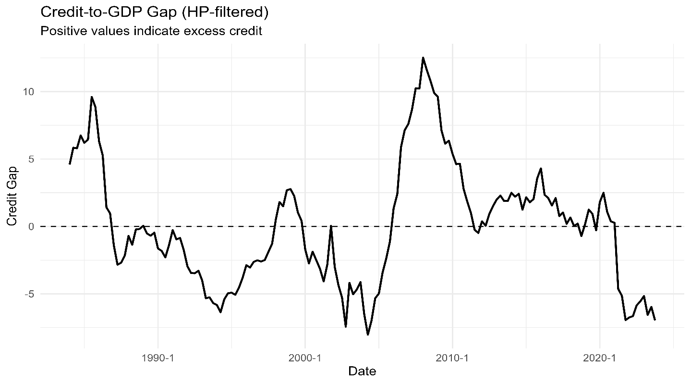
Figure 3. Histogram of threshold variable (head line inflation).
Source: Author’s calculation based on () data.
For the current study, selecting the optimal threshold was undertaken using a grid-searched method due to its ability to minimize model error by ensuring robust regime classification compared to ad hoc or arbitrary methods. Figure 4 contains the results of a histogram showing a bimodal distribution of the HP‑filtered credit‑to‑GDP gap (cgdpg). The grid-search optimal threshold was found to be -3125, splitting the sample size into low and high stress, where the split of the sample for high stress is 83 (47.8%) observations, while for low stress it is 76 (52.2%) observations of 159 observations. The right mode concentrates near 0 to plus two, while the left model is around -5 to -4. The low misclassification risk at the cutoff is shown in the small sliver right of the threshold, which indicate limited overlapping.indicates
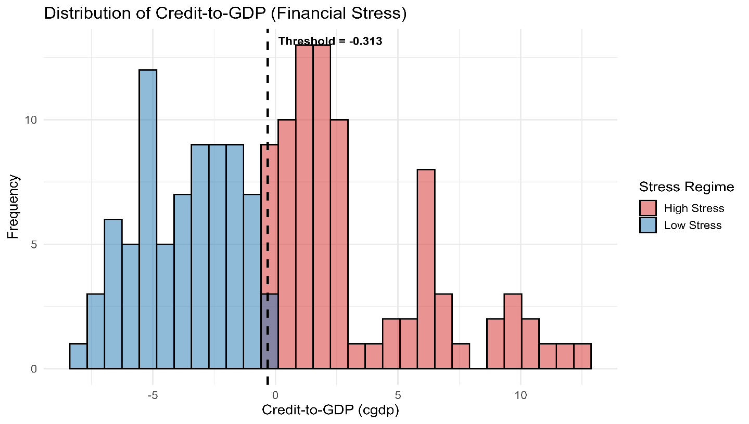
Figure 4. Histogram of threshold variable (head line inflation).
Source: Author’s calculation based on () data.
The economic intuition behind figures 3 and 4 is that the credit-to-GDP gap is the deviation of the credit-to-GDP ratio from its HP-filtered trend. Positive gaps signal the potential buildup of cyclical risk, while the negative gaps indicate slack or deleveraging. Intuitively the edit-to-GDP gap underpins the countercyclical capital buffer framework due to its strong early-warning properties for banking stress (Beltran, Jahan-Parvar, & Paine, 2021; IMF, 2020; Drehmann & Yetman, 2018). While the threshold of −0.3126 classifies that when cgdpg ≤ −0.3126 it is in the low-stress state or not in the high-stress state when it is > −0.3126. Given the cutoff that is below zero, it simply says that as soon as the credit gap is not materially negative, the system is in the high-stress regime already. Aligning the results with the South Africa case study, this raises the flag for vigilance very near trend credit conditions; sustained moves from slightly negative to positive gaps tip the system into the high-stress state where macro-financial transmission, for instance, when the policy rate and property-price shocks are empirically different and more fragile. The 50-50 split implies that South Africa wavered frequently between over-trend leverage and under-trend deleveraging over the sample, which is consistent with using the credit gap as a state variable for macroprudential and policy analysis (Drehmann & Yetman, 2018; IMF, 2020). Back of the envelope metrics indicate that the cumulative distribution function at the cutoff is ≈ 0.478 (76/159); therefore, the threshold is closer to the sample median. Similarly, the proportion of observations in the high-stress share to the right is 0.522 (83/159). This typical rig a bell to the SARB, which should keep −0.3126 as the best current split; however, this needs to be refreshed quarterly and be cross-checked against alternative gap measures on a macroprudential dashboard. Communicate it as a guide-not-rule consistent with Basel guidance on judgmental use of the credit gap. The validity for the regime split was further confirmed using the rolling real HP credit-to-GDP graph as it was reported in figure 5. The rolling real HP credit-to-GDP graph threshold seems to be broadly stable early on, till a discrete downward step, followed by a gentle decline thereafter. Confidence bands widen around the break and narrow again, signaling a period of parameter uncertainty followed by stability.
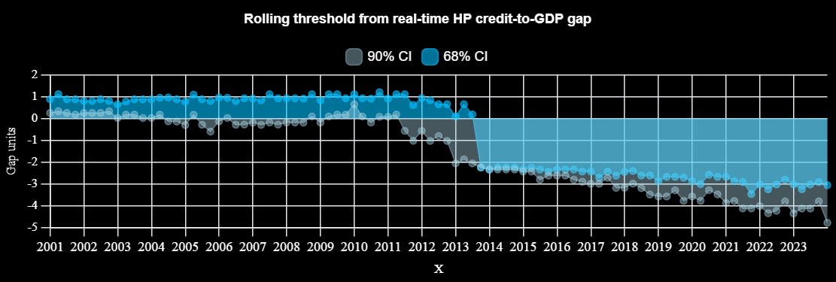
Figure 5. Rolling threshold form real-time HP credit-to GDP gap.
Source: Author’s calculation based on () data.
Despite the level shift, regime classification is robust: the one‑step reclassification rate is 0%, median change 0.00, mean 0.041, with an isolated larger adjustment (max 3.56). For South Africa, this means the stress/calm split is operationally reliable in real time, yet the level of the cutoff drifts; supervisors should refresh it quarterly rather than treat the static −0.3126 as fixed. Gap: credit-to-GDP ratio minus a real-time (one-sided) HP trend with λ = 400 000, re-estimated each quarter on the sample available up to that date (Basel/BIS convention for credit gaps). Threshold per vintage $c_{t}$: minimize the sum of squared residuals of a two-regime mean model for quarterly Tier-1 capital growth (constant in each regime), over a grid of 160 candidates within the sample 5–95% gap range; minimum regime size = 12 observations (Hansen-style threshold regression). Uncertainty: 200 residual-bootstrap replications per vintage; report 68% and 90% percentile intervals for $c_{t}$. Real-time stability: compare the regime classification at date $t$using the old cutoff $c_{t-1}$vs the new $c_{t}$(“one-step reclassification”); this directly addresses real-time reliability concerns for HP-based gaps.
  - Posterior Distribution of Banking Sector Stability Responses
The posterior distribution of banking sector stability responses provides probabilistic insights into how financial stability reacts to economic shocks, capturing uncertainty and enabling robust interpretation of nonlinear dynamics within the estimated model. Figure 6 panelled histogram plot of the posterior distribution of banking sector stability growth responde as the hotizon 12 quarters against all five shocks. Across shocks, both regimes posteriors cluster tightly around zero, with substantial overlap. That means the median four-quarter effect on bank capital is small, and credible regime differences are limited at this short horizon. Any visible tilts are modest: cba and cbpr responses lean slightly positive; cpi is near-neutral; exc is centered at zero with a touch more dispersion; realrp shows the most asymmetry high-stress mass shading slightly negative, consistent with collateral channels weighing on capital when property shocks arrive in vulnerable conditions. However, given the overlap, sign certainty is weak for individual shocks at h=12.

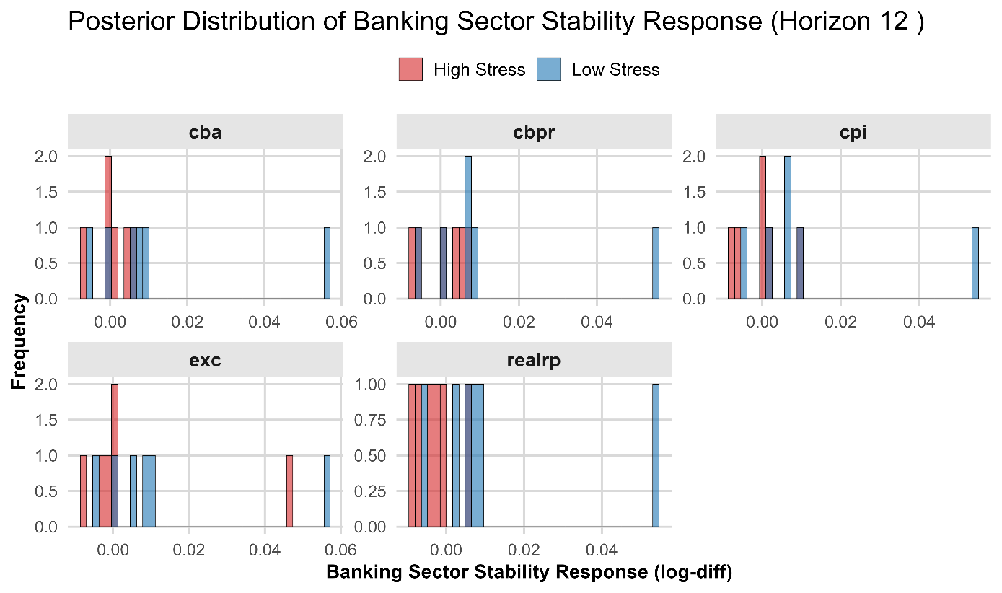
Figure 6. Posterior Distribution of banking sector stability responses.
Source: Author’s calculation based on () data.

Economic meaning for South Africa. Interpreted jointly with the regime split, this says Tier-1 capital adjusts slowly: by one year out, valuation, funding-cost and provisioning channels have not yet produced large, reliable changes in reported capital. In calm periods, small positive cba/cbpr tilts are consistent with liquidity/margin effects aiding internal capital generation; in stress, the slight negative realrp skew points to procyclical leverage (risk-weighted asset growth and overlays outpacing earnings). Practically, for short-horizon policy, this supports: (i) targeted market-functioning operations when stress is acute (fast but modest capital support), (ii) macroprudential attention to real-estate exposures in stressed upswings, and (iii) buffer rebuild in tranquil states, because longer horizons (beyond h=12) are where regime differences and cumulative variance shares typically become meaningful.
  - Impulse Response Functions: Banking Sector Stability Responses Interpretation
The evidence provided by the state-dependent Bayesian SVAR and further supported by the Bayesian IV with state-dependent local projections after controlling for endogeneity, identification, and inference emerged in the main model, especially when the state variable is influenced by the same structural shocks being studied. The results provide a very rich and internally consistent account of how macro financial shocks transmit to banking sector stability in South Africa, with Tier1 capital serving as a central indicator of resilience. The use of the external instrument in the IV framework using the Federal Reserve balance sheet gap isolated exogenous global liquidity shocks by strengthening identification estimation, while for explicitly capturing the role of the financial cycle, the study adopted the credit-to-GDP gap as the state variable. Taken together, the state-dependent Bayesian SVAR as the main model and the Bayesian IV-state-dependent local projections stipulate a consistent narrative that aligns closely with the analytical frameworks employed by institutions such as the South African Reserve Bank, the Federal Reserve System, and the Bank for International Settlements. The finding points overwhelmingly to the existence of nonlinearities in the transmission of stocks to bank capital. Across both models, the persistence and magnitude of response differ markedly between the high-stress and low-stress regimes. This emphasizes the view that the effectiveness of conventional and unconventional monetary policy is state contingent and closely tied to the position of the financial cycle.
SARB balance sheet expansion shock on Tier 1 capital
Strating with the balance sheet expansion shock, , the results from the the Bayesian SVAR indicates an expansion in central bank asset in the low stress generates a positive and persistent increase in on banking sector stability (Tier1 capital). However, the impact have a moderate but stable magnitude and the response remains statistically significant over longer horizons. The result proposes that in tranquil conditions, primarily quantitative easing operates through predictable channels such as improved liquidity conditions, lower funding costs, and gradual portfolio rebalancing. The persistence of the response implies that banks internalise these gains into their capital buffers over time. While, the SVAR reveal a more muted and initially unstable response in the high-stress regime, with the impact effect surrounded by wider credible intervals, signifying weaker immediate transmission. This results signals the impaired functioning of financial intermediation during periods of elevated systemic risk, where liquidity injections may initially be absorbed as precautionary reserves rather than translated into capital strengthening.
While for robustness purposes, the results provided by the Bayesian IV local projection complement those found by the main model. Adopting the Federal Reserve balance sheet gap as the external instrument variable for controlling for exogenous factors, the Bayesian IV with the state-dependent local projections reveals that in the high-stress regime, the response of Tier 1 capital becomes stronger and more persistent at medium to longer horizons following expansion on the central balance sheet. The magnitude of the response increases steadily over time, and the confidence bands narrow, indicating growing statistical significance. This pattern proposes that although the immediate impact of unconventional policy may be weak during the stress episodes, its cumulative effects are substantial once balance sheet repair mechanisms take hold. The results of the main model with the robustness model complement each other, shocking that as much as the main model suffers from endogeneity, the results are still meaningful for policy formulation. The IV approach in this study captures the highlight of the delayed but economically meaningful gains, while the SD-BSVAR outlines the short-run uncertainty and frictions. This results are inline with the study by Gagnon et al. (2011) and Krishnamurthy and Vissing Jorgensen (2013), who find unconventional monetary policy transmission to operate with lags through indirect channels such as asset price revaluation and risk taking incentives.

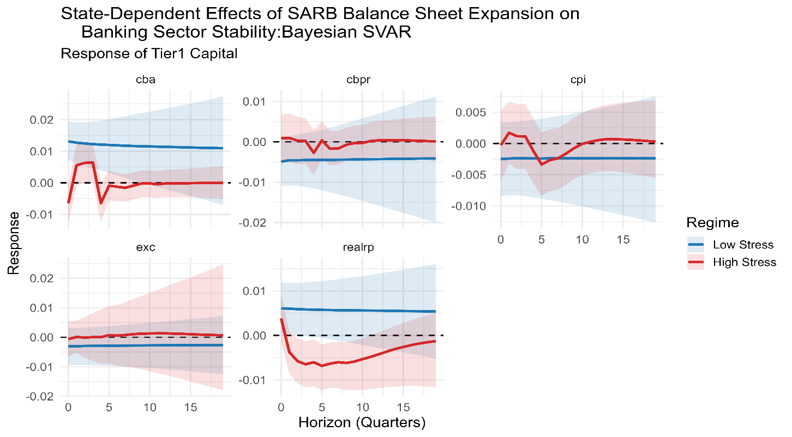
Figure 7. Generated impulse responses of banking sectore stability from the state-dependen Bayesian SVAR.
Source: Author’s calculation based on () data.

Policy rate shock on Tier 1 capital
Turning to the policy rate shock, both the main model and the robustness model relatively indicate a weak and statistically insignificant effect on Tier 1 capital in the low-stress regime. The SD-BSVAR reveals a small magnitude with no persistence; however, it has a slight negative response, which this pattern is confirmed by the Bayesian IV with state-dependent local projections, with responses that are close to zero and surrounded by wide uncertainty bands. While in the high-stress regime, the results exhibit some evidence of a stronger response, more especially in the IV framework; conversely, the effects stay modest compared to those of balance sheet expansion. This results advises that during the period of financial distress, traditional interest rate channel is less effective in influencing bank capital. This finding is consistent with the view that during stress episodes, financial frictions such as credit rationing and elevated risk premia weaken the pass through of policy rates to bank balance sheets, as highlighted in Bernanke and Gertler (1989) and more recently in BIS analyses of monetary transmission under financial stress.

Inflation shock on Tier 1 capital
In both the main model and the robustness model, a clear and consistent negative effect on Tier 1 capital across both regimes is documented following a shock on inflation, with the effect being significantly stronger in the high-stress regime. Inflation leads to a gradual decline in bank capital in the SD-BSVAR framework, with the response becoming more pronounced over time, while the declining impact becomes sharper and more persistent in the high-stress conditions in the IV approach. This result mirrors the indirect effect of inflation on asset quality and funding conditions as well as the erosion of real capital buffers as a result of the increasing price levels. While in the high-stress regimes, these effects are amplified by existing weaknesses in the banking system, leading to larger and more persistent declines in capital adequacy. For both of these models to align in the response of Tier 1 capital to inflation shock strengthens the argument that price stability is a key prerequisite for financial stability, a principle that is central to the policy frameworks of both advanced and emerging market central banksbanks.

Exchange rate depreciation shock on Tier 1 capital
The exchange rate shock reveals a nuanced and interesting pattern, as the results of the main model and the robust model show relatively small and statistically insignificant effects on Tier 1 capital in the low-stress regime. While the IV results show a positive and increasingly significant response, a similar but less pronounced pattern is shown in the SD-BSVAR in the high-stress regime. This shows that during the period of stress, exchange rate depreciation may have a stabilizing effect on bank capital, possibly through improved competitiveness of export-oriented sectors or valuation effects on foreign currency assets. Nevertheless, the relatively wide confidence bands in both models indicate that this channel is subject to considerable uncertainty, reflecting the complex and often opposing effects of exchange rate movements on balance sheets in emerging markets.

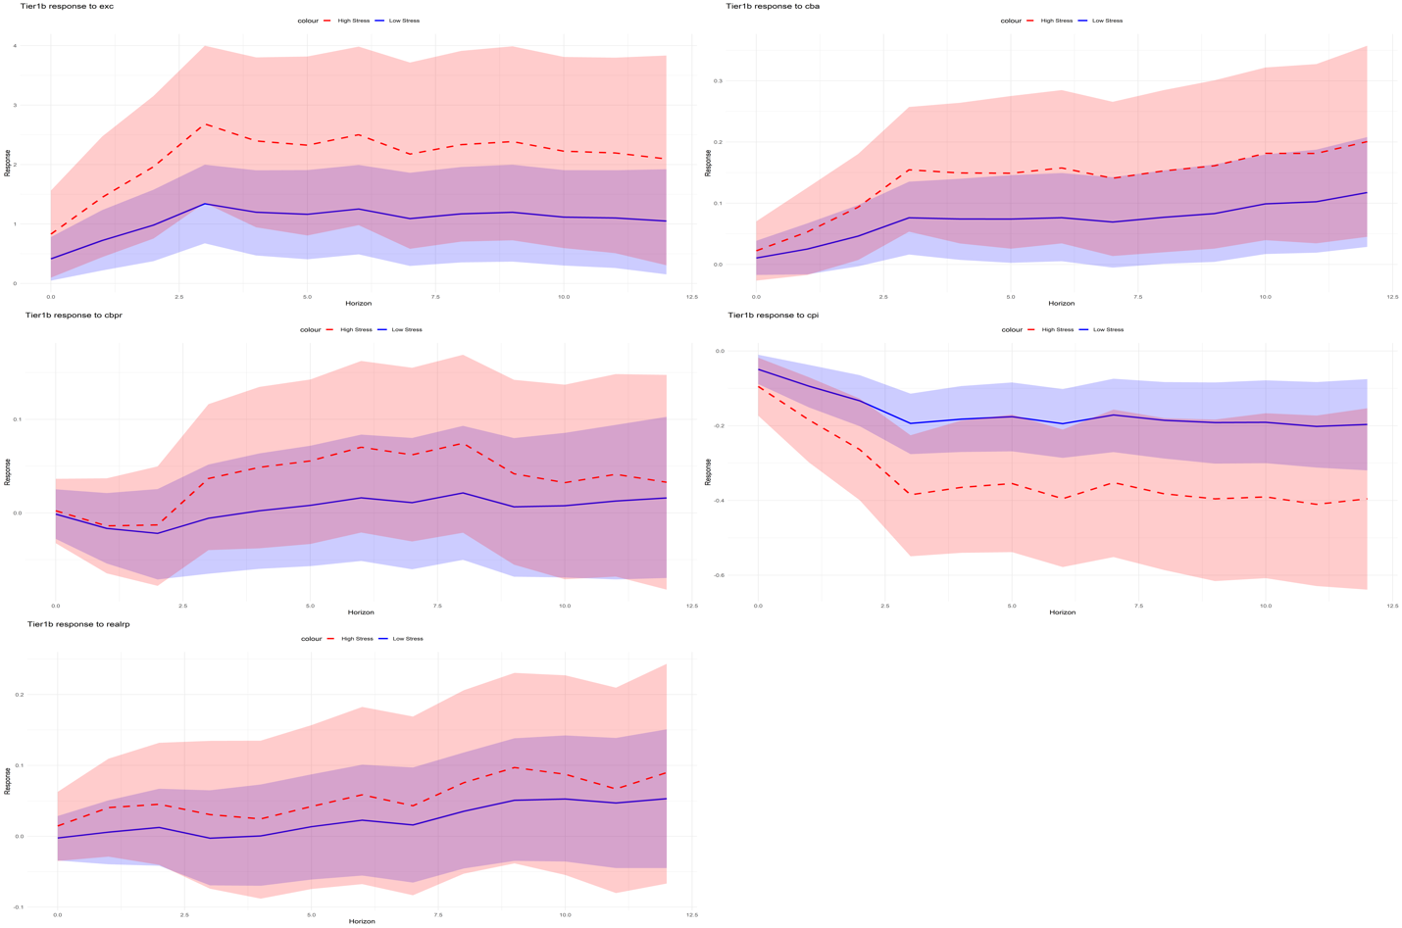
Figure 8. Generated impulse responses of banking sector stability from the Bayesian IV with state-dependent local projections.
Source: Author’s calculation based on WDI (2025) and SWIID (Solt, 2020) data.

Real residential property price shock on Tier 1 capital
In both, the main and the robustness models, the real housing price shock exhibits strength with a significantly larger positive effect on Tier 1 capital in the high-stress regime. In the SD-BSVAR, in the low regime, the response is positive and persistent; it primarily declines before recovering and turning positive in the high-stress regime. However, a positive response throughout and rise steadily over time, more especially in the high stress, are documented in the IV framework. These results reveal the significance of the asset price channel in determining banking sector stability. Logically, collateral values improve when house prices improve, strengthening bank balance sheets and reducing default risk. However, these effect are amplified during the stress periods as improvements in asset prices can trigger nonlinear feedback loops that further support both bank capital and borrower solvency. The results are inline with the financial accelerator framework developed by Bernanke et al. (1999) and further elaborated in recent BIS work on the role of asset prices in financial cycles.
  - Economics Meaning and Cross shock synthesis and regime comparisons
I NEED TO TOUCH ON THIS; IT WOULD BE READY BY THE 10TH OF APRIL.

  - Forecast Error Variance Decomposition and Cumulative Forecast Error Variance Decomposition
I NEED TO TOUCH ON THIS; IT WOULD BE READY BY THE 10TH OF APRIL.

- Conclusion and Policy Implications for the South African Reserve bank

The combined results of the study point to a consistent and policy-critical conclusion. Firstly, the results point out that the transmission of macro-financial shocks to banking sector stability is nonlinear and highly contingent on the position of the financial cycle in South Africa. Tier 1 capital responds asymmetrically to shocks across both modeling approaches, with materially different statistical significance, persistence, and magnitudes in high-stress versus low-stress regimes. The convergence on these results across identification strategies further strengthens the robustness of the finding and offers a credible empirical foundation for policy. The central conclusion of this study is that financial conditions act as an amplifier of shocks. In high-stress environments, the responses are less predictable as they are more volatile and larger in magnitude, reflecting binding balance sheet constraints and heightened uncertainty. In contrast, in the low-stress periods, the banking sector exhibits resilience, with responses to asset price, exchange rate, and monetary policy shocks that are generally moderate, stable, and more precisely estimated. This is evident that in stress conditions these macro-finaical shock adverse generate disproportionately negative effects on Tier1 capital, while on the other side certatain polict interventions (balance sheet expansion) seems to have significant stabilizing effect during elevated stress, eventhough their effectiveness may depend on the severity of financial frictions.
The finding of this study exposes the weakening of conventional monetary policy transmission in the context of financial stress. There are ambiguous or limited effects of changes in interest rates on banking sector stability in elevated financial stress, pointing out that the traditional interest rate channel is impaired when financial intermediaries face capital constraints. In contrast, macroprudential measures and unconventional tools play a more crucial role influencing bank resilience under such conditions. This strengthens the rising consensus in the international policy literature calling for joint calibration and state contingency on monetary and financial stability policies. The Bank for International Settlements (BIS) (2026, 2024) and the South African Reserve Bank (SARB) (2024a, 2024b) have pointed out that the interaction between monetary and macroprudential policy is essential in safeguarding systemic vulnerabilities and financial cycle risks, while SARB study argues on the the SARBimportance of an integrated and forward-looking policy framework.
From a policy perspective, this study reveals numerous actionable policy implementation for the South African central bank and other emerging market central banks. First, macroprudential policy should play a central role in stabilizing the financial system. Therefore, instruments such as loan-to-value limits, countercyclical capital buffers, and sectoral capital requirements should be actively adjusted in response to evolving financial conditions to mitigate nonlinear amplification effects. Second, based on the results of this study, there is a need for the central bank to formally integrate financial cycle indicators into the policy framework, particularly the credit to GDP gap. The credit-to-GDP gap stipulates crucial real-time information regarding systemic risk conditions; therefore, it can serve as a trigger for countercyclical policy responses. Third, the results underline the significance of external factors, especially global liquidity conditions. Shock originating from advanced markets can prevail, amplifying domestic effects during the elevated period for emerging markets like South Africa. These further call for policy frameworks that can moderate the impact of volatile capital flows and highlight the importance for robust macroprudential buffers. Fourth, the findings reveal that conventional monetary policy becomes less effective; this supports the evidence for using a broader policy toolkit such as balance sheet policies, liquidity provision, and coordination with regulatory authorities during periods of elevated stress to support financial intermediation. However, to avoid unintended consequences, such as asset price distortions and excessive risk-taking in subsequent low-stress periods, these interventions needs to be carefully calibrated.

Reference
Adrian, T., & Shin, H. S. (2010). Liquidity and leverage. Journal of Financial Intermediation, 19(3), 418–437.
Auerbach, A. J., & Gorodnichenko, Y. (2012). Measuring the output responses to fiscal policy. American Economic Journal: Economic Policy, 4(2), 1–27.
Bagehot, W. (1873). Lombard Street: A description of the money market. London, United Kingdom: Henry S. King.
Bagehot, W. (1873). Lombard Street: A description of the money market. London: Henry S. King.
Bernanke, B. S., Gertler, M., & Gilchrist, S. (1999). The financial accelerator in a quantitative business cycle framework. In J. B. Taylor & M. Woodford (Eds.), Handbook of macroeconomics (Vol. 1, pp. 1341–1393). Elsevier.
Bagehot, W. (1873). Lombard Street: A description of the money market. London, United Kingdom: Henry S. King.
Bank for International Settlements. (2016). Exchange rate pass-through: What has changed since the crisis? (BIS Working Papers No. 583).
Bank for International Settlements. (2018). Central banks and debt: Emerging risks to the effectiveness of monetary policy in Africa? (BIS Papers No. 99).
Beltran, D. O., Jahan-Parvar, M. R., & Paine, F. A. (2021). Optimizing credit gaps for predicting financial crises: Modelling choices and trade-offs (IFDP 1307). Board of Governors of the Federal Reserve System.
Bernanke, B. S. (2020). The new tools of monetary policy. American Economic Review, 110(4), 943–983.
Bernanke, B. S., Gertler, M., & Gilchrist, S. (1999). The financial accelerator in a quantitative business cycle framework. In J. B. Taylor & M. Woodford (Eds.), Handbook of macroeconomics (Vol. 1, pp. 1341–1393). Amsterdam, Netherlands: Elsevier.
Bernanke, B. S., Gertler, M., & Gilchrist, S. (1999). The financial accelerator in a quantitative business cycle framework. In J. B. Taylor & M. Woodford (Eds.), Handbook of macroeconomics (Vol. 1, pp. 1341–1393). Amsterdam, Netherlands: Elsevier.
BIS (Bank for International Settlements). (2015). The international transmission of monetary policy – lessons learnt in South Africa (BIS Papers No. 78, SA contribution). Bank for International Settlements
BIS Working Paper No. 586). Bank for International Settlements.
Borio, C., & Zhu, H. (2012). Capital regulation, risk taking and monetary policy. Journal of Financial Stability, 8(4), 236–251.
Borio, C., & Zhu, H. (2012). Capital regulation, risk taking and monetary policy. Journal of Financial Stability, 8(4), 236–251.
Bruns, M., & Piffer, M. (2020). Bayesian structural VAR models: A new approach for prior beliefs on impulse responses (KCL DAFM Working Paper 2020/2). King’s College London.
Caldara, D., & Herbst, E. (2016). Monetary policy, real activity, and credit spreads: Evidence from Bayesian proxy SVARs. Finance and Economics Discussion Series 2016-049. Board of Governors of the Federal Reserve System.
Christopher Sims, C. A. (1980). Macroeconomics and reality. Econometrica, 48(1), 1–48. https://doi.org/10.2307/1912017
Christopoulos, D., McAdam, P., & Tzavalis, E. (2023). Threshold endogeneity in threshold VARs: An application to monetary state dependence (RWP 23-09). Federal Reserve Bank of Kansas City.
Demirgüç-Kunt, A., Detragiache, E., & Merrouche, O. (2013). Bank capital: Lessons from the financial crisis. Journal of Money, Credit and Banking, 45(6), 1147–1164.
Drehmann, M., & Yetman, J. (2018). Why you should use the Hodrick–Prescott filter – at least to generate credit gaps (BIS Working Paper No. 744). Bank for International Settlements.
Drehmann, M., & Yetman, J. (2021). Which credit gap is better at predicting financial crises? A comparison of univariate filters. International Journal of Central Banking, 17(4), 225–260.
Fowkes, D. (2022). Not so easy: Why quantitative easing is inappropriate for South Africa (SARB Working Paper WP/22/05). South African Reserve Bank.
Gambacorta, L., & Karmakar, S. (2016). Leverage and risk-weighted capital requirements (
Gagnon, J., Raskin, M., Remache, J., & Sack, B. (2011). The financial market effects of the Federal Reserve’s large scale asset purchases. International Journal of Central Banking, 7(1), 3–43.
Gary Koop, G., & Dimitris Korobilis, D. (2010). Bayesian multivariate time series methods for empirical macroeconomics. Foundations and Trends in Econometrics, 3(4), 267–358.
Greenwood-Nimmo, M., Steenkamp, D., & van Jaarsveld, R. (2022). A bank-level analysis of interest rate pass-through in South Africa (SARB Working Paper WP/22/06). South African Reserve Bank.
International Monetary Fund. (2019). Exchange rate volatility and pass-through to inflation in South Africa (IMF Working Paper 19/277). IMF.
James Stock, J. H., & Mark Watson, M. W. (2007). Why has U.S. inflation become harder to forecast? Journal of Money, Credit and Banking, 39(s1), 3–33.
Joyce, M., Tong, M., & Woods, R. (2011). The United Kingdom’s quantitative easing policy: Design, operation and impact. Bank of England Quarterly Bulletin, 51(3), 200–212.
Joyce, M., Tong, M., & Woods, R. (2011). The United Kingdom’s quantitative easing policy: Design, operation and impact. Bank of England Quarterly Bulletin, 51(3), 200–212.
Kabundi, A., & Mlachila, M. (2018). Monetary policy credibility and exchange rate pass-through in South Africa (IMF Working Paper 18/173). IMF.
Lekhuleni, T. I., & Ndlovu, G. (2023). The dynamic effect of macroeconomic factors on housing prices: Evidence from South Africa. PLOS ONE, 18(11), e0290552.
Msiska, W., Sikhosana, A., & Vermeulen, C. (2025). The South African credit gap as real-time early warning indicator of financial imbalances (Financial Stability Department Topical Briefing TB-05). South African Reserve Bank.
Pirozhkova, E., & Viegi, N. (2024). The bank lending channel of monetary policy transmission in South Africa (SARB Working Paper WP/24/19). South African Reserve Bank.
Robert Litterman, R. B. (1986). Forecasting with Bayesian vector autoregressions—Five years of experience. Journal of Business & Economic Statistics, 4(1), 25–38.
SARB (South African Reserve Bank). (2024). Delivering the SARB strategy. South African Reserve Bank.
SARB (South African Reserve Bank). (2025). Box 2: Understanding the SARB’s balance sheet (Quarterly Bulletin Box). South African Reserve Bank.
SARB (South African Reserve Bank). (2025). Lessons from the COVID-19 pandemic in South Africa (Financial Sector Contingency Forum report). South African Reserve Bank.
Sibande, X., & Milne, A. (2024). The impact of Basel III implementation on bank lending in South Africa (SARB Working Paper WP/24/04). South African Reserve Bank.
Simo-Kengne, B. D., Gupta, R., & Aye, G. C. (2013). Macro shocks and house prices in South Africa. Journal of Real Estate Portfolio Management, 19(2), 179–194.
Thomas Doan, T., Litterman, R., & Sims, C. (1984). Forecasting and conditional projection using realistic prior distributions. Econometric Reviews, 3(1), 1–100.
Tobin, J. (1969). A general equilibrium approach to monetary theory. Journal of Money, Credit and Banking, 1(1), 15–29.
You, Z. (2026). How well are state-dependent local projections capturing nonlinearities? arXiv preprint arXiv:2602.14455.
Adrian, T., & Liang, N. (2018). Monetary policy, financial conditions, and financial stability. International Journal of Central Banking, 14(1), 73–131.
Bank for International Settlements. (2021). Asset prices and financial stability. BIS Annual Report.
Bank for International Settlements. (2022). The effectiveness of QE in advanced and emerging markets. BIS Quarterly Review.
Bank for International Settlements. (2023). Global liquidity and financial cycles. BIS Working Papers.
Borio, C., Disyatat, P., & Juselius, M. (2023). Rethinking inflation dynamics in a financial cycle framework. BIS Working Paper.
Bruno, V., & Shin, H. S. (2015). Capital flows and the risk taking channel of monetary policy. Journal of Monetary Economics, 71, 119–132.
Kiyotaki, N., & Moore, J. (1997). Credit cycles. Journal of Political Economy, 105(2), 211–248.
Krishnamurthy, A., & Vissing Jorgensen, A. (2011). The effects of quantitative easing on interest rates. Brookings Papers on Economic Activity, 2, 215–287.
South African Reserve Bank. (2022). Monetary policy and financial stability interactions in South Africa. SARB Working Paper Series.
Bank for International Settlements. (2022). Unconventional monetary policy and financial stability. BIS Quarterly Review.
Borio, C., Disyatat, P., & Juselius, M. (2023). Rethinking inflation dynamics in a financial cycle framework. BIS Working Paper.
Bruno, V., & Shin, H. S. (2015). Capital flows and the risk taking channel of monetary policy. Journal of Monetary Economics, 71, 119 to 132.
Kiyotaki, N., & Moore, J. (1997). Credit cycles. Journal of Political Economy, 105(2), 211 to 248.
Merrino, S. (2021). State dependent fiscal multipliers and financial dynamics in South Africa. South African Reserve Bank Working Paper .
South African Reserve Bank. (2023). Financial Stability Review. .
South African Reserve Bank. (2024). Financial stability monitoring and assessment framework. .
Auerbach, A. J., & Gorodnichenko, Y. (2012). Measuring the output responses to fiscal policy. American Economic Journal Economic Policy, 4(2), 1 to 27.
Bernanke, B. S., & Gertler, M. (1989). Agency costs, net worth, and business fluctuations. American Economic Review, 79(1), 14 to 31.
Bernanke, B. S., Gertler, M., & Gilchrist, S. (1999). The financial accelerator in a quantitative business cycle framework. Handbook of Macroeconomics, 1, 1341 to 1393.
Gagnon, J., Raskin, M., Remache, J., & Sack, B. (2011). The financial market effects of the Federal Reserve large scale asset purchases. International Journal of Central Banking, 7(1), 3 to 43.
Jordà, Ò., Schularick, M., & Taylor, A. M. (2013). When credit bites back. Journal of Money, Credit and Banking, 45(s2), 3 to 28.
Kiyotaki, N., & Moore, J. (1997). Credit cycles. Journal of Political Economy, 105(2), 211 to 248.
Krishnamurthy, A., & Vissing Jorgensen, A. (2013). The effects of quantitative easing on interest rates. Brookings Papers on Economic Activity, 44(2), 215 to 287.
Bank for International Settlements. (2024). Monetary policy in the 21st century: Lessons learned and challenges ahead. BIS Annual Economic Report.
Bank for International Settlements. (2016). Interaction between macroprudential and monetary policies. BIS Papers.
South African Reserve Bank. (2024a). Macroprudential policy framework and decision-making process. Pretoria: SARB.
South African Reserve Bank. (2024b). Financial stability monitoring and assessment framework. Pretoria: SARB.
Adrian, T., & Shin, H. S. (2010). Liquidity and leverage. Journal of Financial Intermediation, 19(3), 418 to 437.
Auerbach, A. J., & Gorodnichenko, Y. (2012). Measuring the output responses to fiscal policy. American Economic Journal Economic Policy, 4(2), 1 to 27.
Bank for International Settlements. (2016). Interaction between monetary and macroprudential policies. BIS Papers.
Bank for International Settlements. (2024). Annual Economic Report. Basel: BIS.
Bernanke, B. S., Gertler, M., & Gilchrist, S. (1999). The financial accelerator in a quantitative business cycle framework. In J. B. Taylor & M. Woodford (Eds.), Handbook of Macroeconomics (Vol. 1, pp. 1341 to 1393). Elsevier.
Gagnon, J., Raskin, M., Remache, J., & Sack, B. (2011). The financial market effects of large scale asset purchases. International Journal of Central Banking, 7(1), 3 to 43.
Jordà, Ò., Schularick, M., & Taylor, A. M. (2013). When credit bites back. Journal of Money, Credit and Banking, 45(s2), 3 to 28.
Kiyotaki, N., & Moore, J. (1997). Credit cycles. Journal of Political Economy, 105(2), 211 to 248.
Krishnamurthy, A., & Vissing Jorgensen, A. (2013). The effects of quantitative easing on interest rates. Brookings Papers on Economic Activity, 44(2), 215 to 287.
Brink, N., & Kock, M. (2010). Central bank balance sheet policy in South Africa and its implications for money-market liquidity. South African Reserve Bank Working Paper.
Gumata, N., & Ndou, E. (2021). Achieving price, financial and macro-economic stability in South Africa: The role of the central bank balance sheet. Springer.
South African Reserve Bank. (2023). Financial Stability Review. Pretoria: South African Reserve Bank.
South African Reserve Bank. (2024). Did Basel III reduce bank spillovers in South Africa? SARB Working Paper.
South African Reserve Bank. (2025). Annual Report 2024/25. Pretoria: South African Reserve Bank.
Vermeulen, C. (2024). Quantitative easing and central bank asset purchases in South Africa: A DSGE approach. ERSA Working Paper Series.
Auerbach, A. J., & Gorodnichenko, Y. (2012). Measuring the output responses to fiscal policy. American Economic Journal Economic Policy, 4(2), 1 to 27.
Bank for International Settlements. (2016). Interaction between monetary and macroprudential policies. BIS Papers.
Bank for International Settlements. (2024). Annual Economic Report. Basel: BIS.
Bagehot, W. (1873). Lombard Street: A description of the money market. London: Henry S. King.
Bernanke, B. S., Gertler, M., & Gilchrist, S. (1999). The financial accelerator in a quantitative business cycle framework. In Taylor, J. B., & Woodford, M. (Eds.), Handbook of Macroeconomics (Vol. 1, pp. 1341 to 1393). Elsevier.
Borio, C., Disyatat, P., & Juselius, M. (2017). Rethinking potential output: Embedding information about the financial cycle. Oxford Economic Papers, 69(3), 655 to 677.
Gagnon, J., Raskin, M., Remache, J., & Sack, B. (2011). The financial market effects of large scale asset purchases. International Journal of Central Banking, 7(1), 3 to 43.
Jordà, Ò., Schularick, M., & Taylor, A. M. (2013). When credit bites back. Journal of Money, Credit and Banking, 45(s2), 3 to 28.
Krishnamurthy, A., & Vissing Jorgensen, A. (2013). The effects of quantitative easing on interest rates. Brookings Papers on Economic Activity, 44(2), 215 to 287.
Miranda-Agrippino, S., & Rey, H. (2020). U.S. monetary policy and the global financial cycle. Review of Economic Studies, 87(6), 2754 to 2776.
Rey, H. (2015). Dilemma not trilemma: The global financial cycle and monetary policy independence. NBER Working Paper No. 21162.
Tobin, J. (1969). A general equilibrium approach to monetary theory. Journal of Money, Credit and Banking, 1(1), 15 to 29.
Vayanos, D., & Vila, J. L. (2021). A preferred habitat model of the term structure of interest rates. Econometrica, 89(1), 77 to 112.

